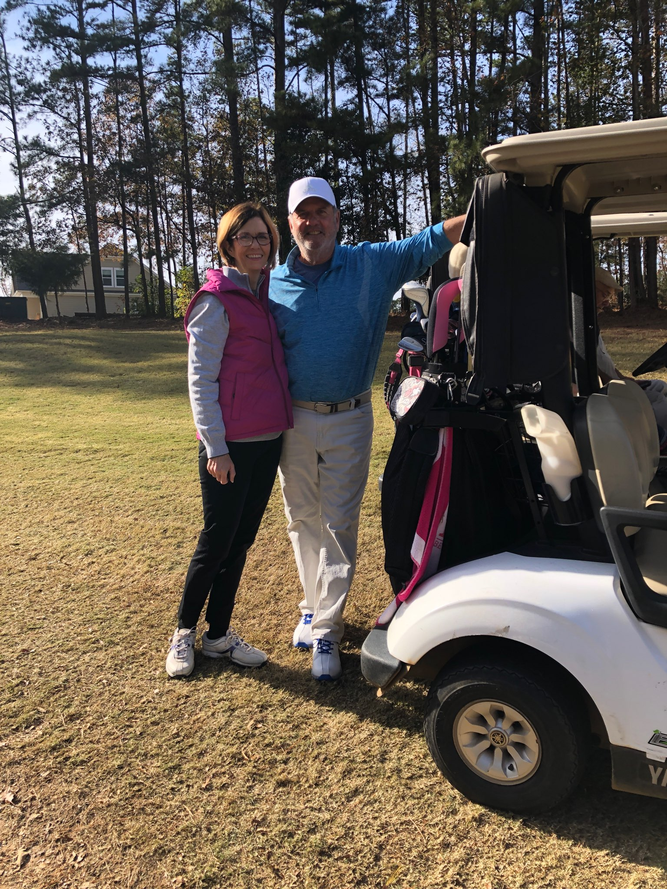  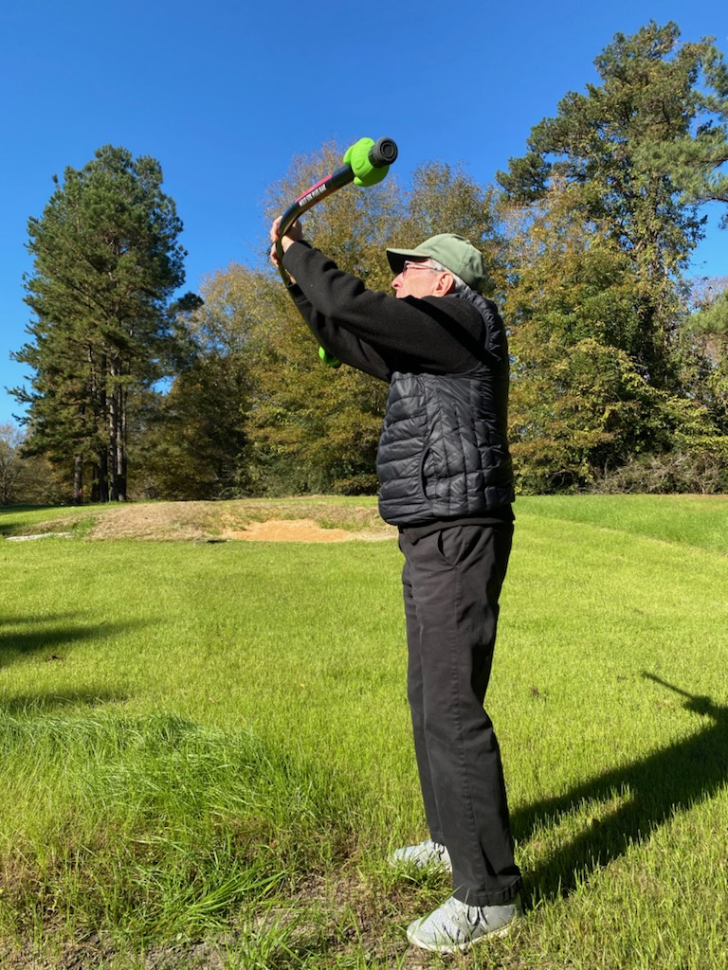  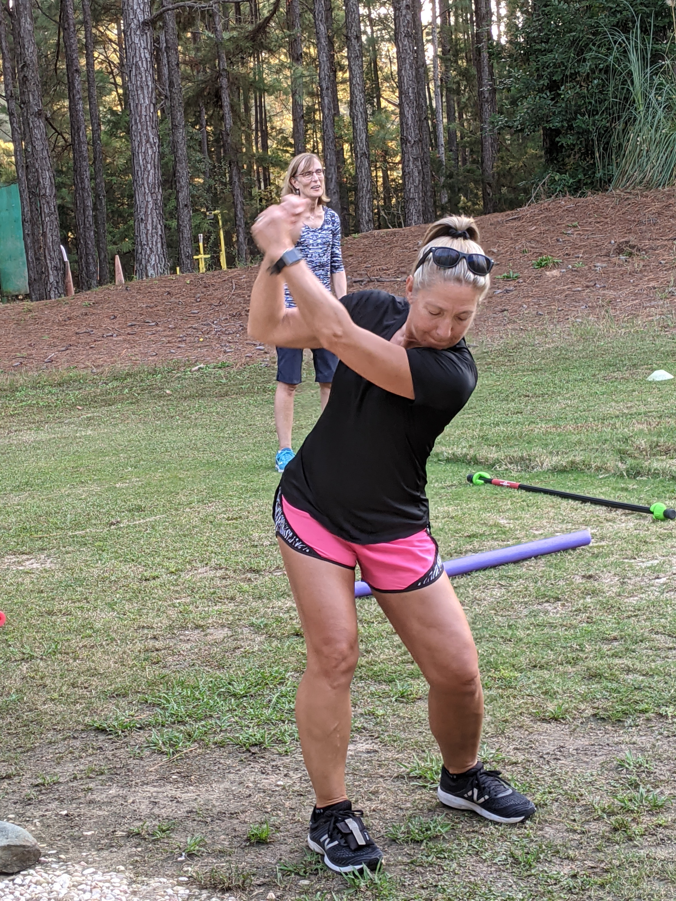 |  | Angie Duckworth owner of Duckworth Fitness & George Bryan Golf Academy have joined to offer a new Golf Fitness Academy.  Angie wants to help people move naturally so they can better enjoy the things they love most.  Coming from a once sedentary and unfit background, She believe wholeheartedly that movement is a necessary component of physical and mental wellness. In addition to teaching online and in person, Angie loves pilates, golf and her is passion for the  Livestong and Parkinson Programs.  She is a life learn and holds a Personal Trainer certification, Corrective Exercise Specialist along with a Fitness Nutrition Certification through National Association of Sports Medicine. She understands how gaining a deeper awareness of how your body moves can improve every aspect of your life.  She want to help improve the quality of others life and make it accessible to all.  She also hold a specialty certification in Pilates, Bootcamp, & Group Fitness.  She would love helping you achieve your health and fitness goals and believes that it’s never too late to get your body moving and enjoying the things you love. |  | Present  Golf  Fitness Academy  (803) 781-2063  www.georgebryangolfacademy.com  614/554-9391  ducky8224@gmail.com  &

Golf Fitness Options
One on One 1 Hour session $90
Half Hour session $50
Packages available starting at $250

Women’s Only
Bootcamp and Strength
Zoom Options
Monthly Membership $129
Any Classes, No limit! Monthly content theme to motivate.

Ten Classes Package to test the waters.
Expires in 8 weeks from purchase. $99
No makeups for holidays or roll over.

Online Content Only Package $99
For the independent fitness minded.

Includes choice of themed content below and goal setting mapping.
Quick Start Exercise Guide
Crush your Cravings
Body Confidence Guide

All sessions begin with a comprehensive fitness interview.
Establish short and long term goals,
Past injuries, and posture assessment.
We will focus on the whole body
O Flexibility • Range of Motion • Strength • Posture • Balance • Mind-Set

George Byran Golf and Duckworth Fitness are merging a holistic approach to Fitness and Golf. We want you to feel strong from the inside out, enjoying family and life; especially golf.

Understanding how your strength, posture, balance, and flexibility affects the joints and muscles will help you control your swing. Please call to set up an initial Evaluation. You will be assigned a program and work with a NASM certified trainer and/or a golf professional.

Weekly videos and recommended at-home exercises are what makes our program complete Start now to reap the benefits
Better movement equals playing better golf!

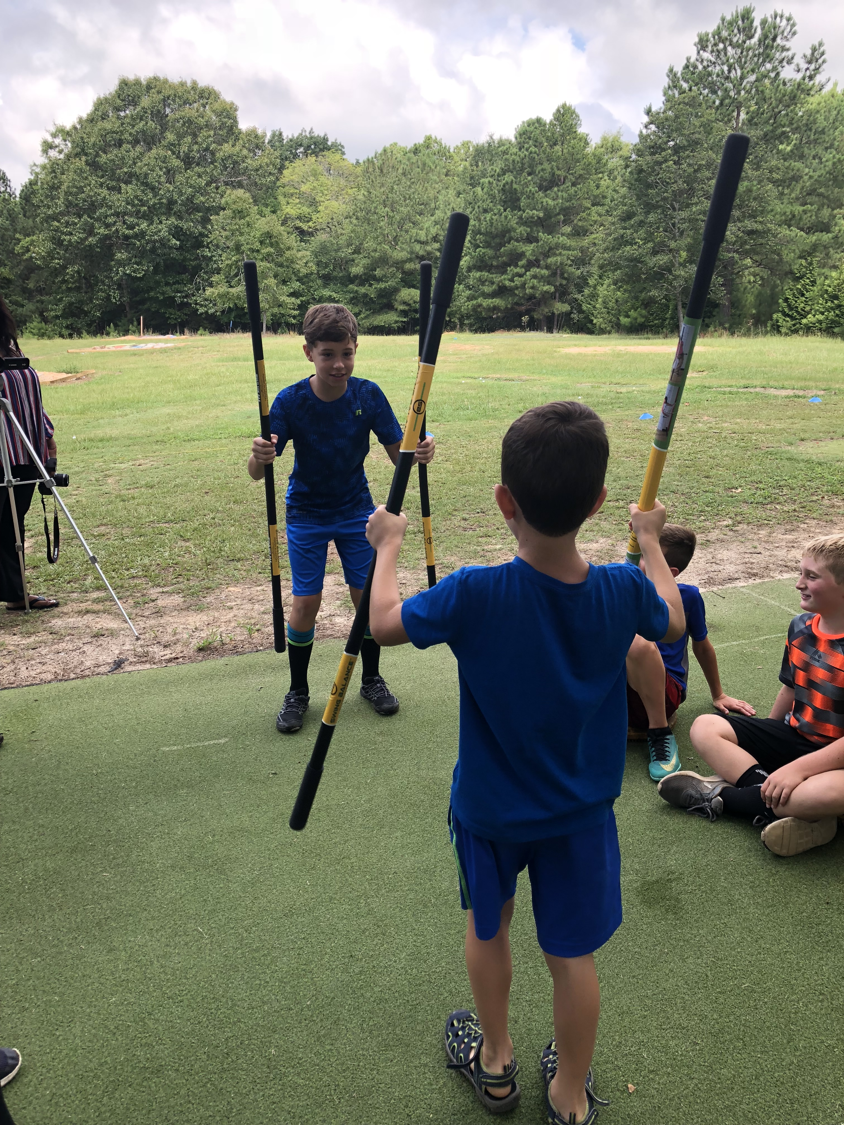

Classes are conducted online or
GBGA Learning Center
1080 Mt Vernon Church Road
Chapin, SC 29036

